
Department of BES-1
DATA STRUCTURES THROUGH PYTHON(24SC1204)
I/IV-B.Tech-(II Sem), Academic Year: 2024-2025

Session-36 (Graph Traversal Techniques)
Instructional Objective:
- To learn the concept of Graph traversal techniques
Learning Outcomes:
1. Students come to know about graph traversal – BFS
Introduction:
Graph traversal is a technique used for a searching vertex in a graph. The graph traversal is also used to decide the order of vertices is visited in the search process. A graph traversal finds the edges to be used in the search process without creating loops. That means using graph traversal we visit all the vertices of the graph without getting into looping path.
There are two graph traversal techniques and they are as follows...
- BFS (Breadth First Search)
Explanation:

BFS (Breadth First Search)
BFS traversal of a graph produces a spanning tree as final result. Spanning Tree is a graph without loops. We use Queue data structure with maximum size of total number of vertices in the graph to implement BFS traversal.
Steps to implement BFS traversal...
- Step 1 - Define a Queue of size total number of vertices in the graph.
- Step 2 - Select any vertex as starting point for traversal. Visit that vertex and insert it into the Queue.
- Step 3 - Visit all the non-visited adjacent vertices of the vertex which is at front of the Queue and insert them into the Queue.
- Step 4 - When there is no new vertex to be visited from the vertex which is at front of the Queue then delete that vertex.
- Step 5 - Repeat steps 3 and 4 until queue becomes empty.
- Step 6 - When queue becomes empty, then produce final spanning tree by removing unused edges from the graph

Example
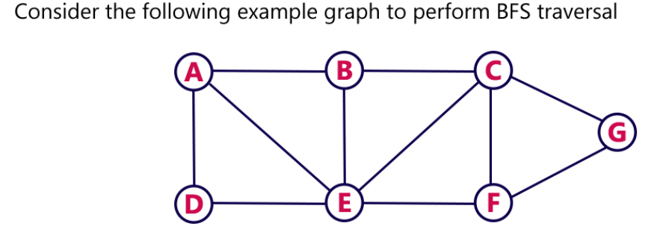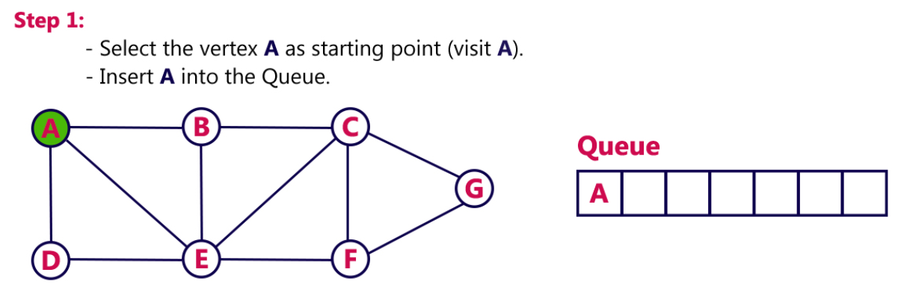
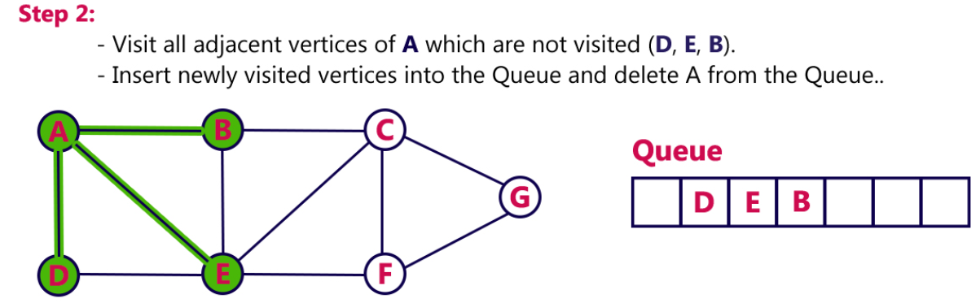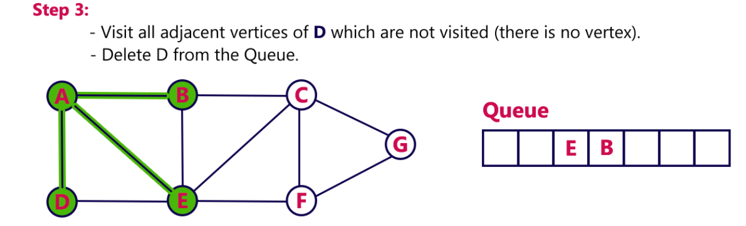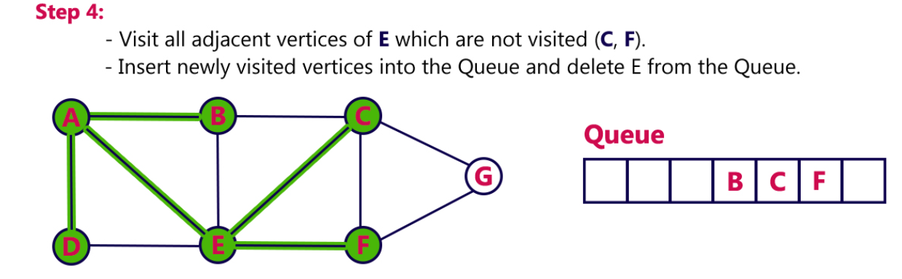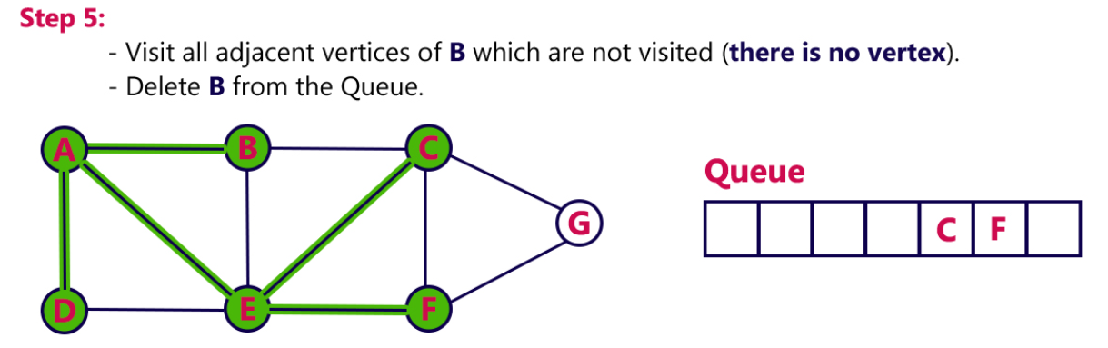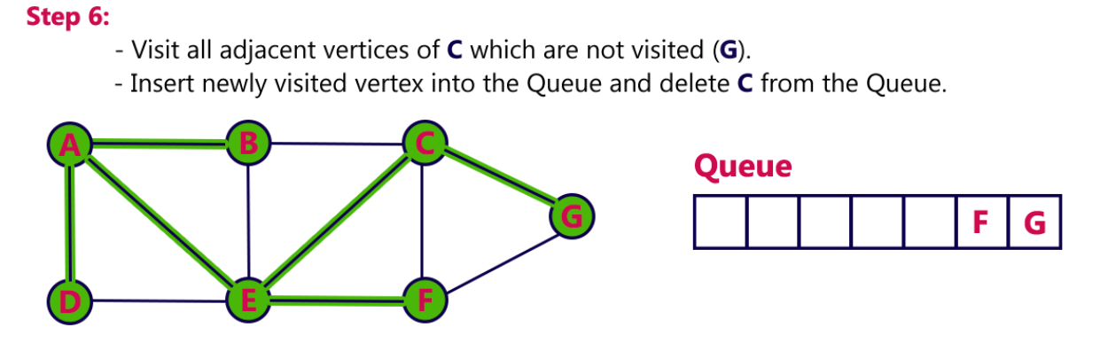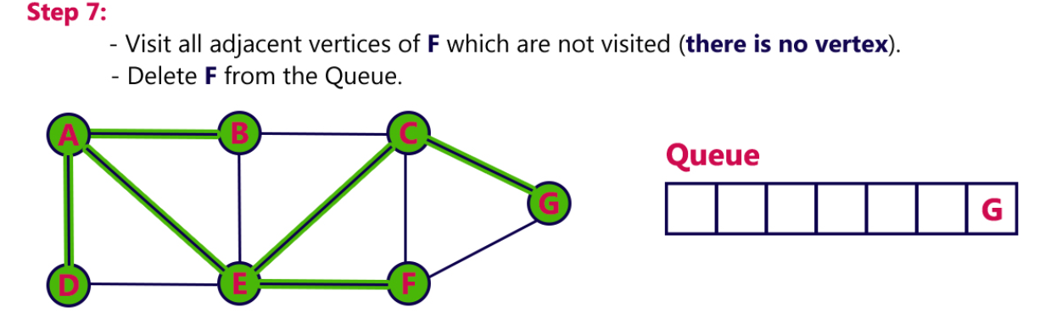
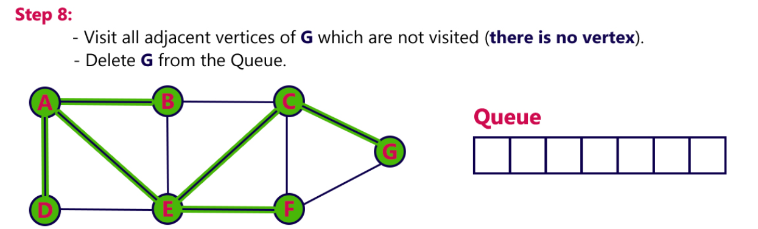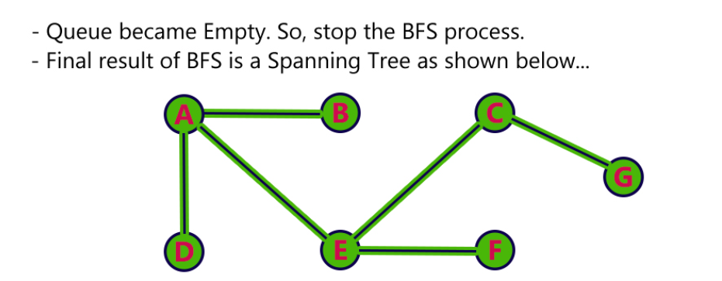

Review questions:
- What is BFS?
- How queue and stacks are implemented?

Summary:
In this session, it was discussed about how to traverse a graph using BFS
Self-assessment questions:

1. Breadth First Search is equivalent to which of the traversal in the Binary Trees?
a) Pre-order Traversal
b) Post-order Traversal
c) Level-order Traversal
d) In-order Traversal

Answer:-C

2. Time Complexity of Breadth First Search is? (V – number of vertices, E – number of edges)
a) O(V + E)
b) O(V)
c) O(E)
d) O(V*E)
Answer: - A
Terminal questions
CLASSROOM DELIVARY PROBLEMS
  - BFS: Shortest Reach in a Graph
Reference Link: https://www.hackerrank.com/challenges/ctci-bfs-shortest-reach/problem
Consider an undirected graph consisting of n nodes where each node is labeled from 1to n and the edge between any two nodes is always of length 6. We define node s to be the starting position for a BFS. Given a graph, determine the distances from the start node to each of its descendants and return the list in node number order, ascending. If a node is disconnected, it's distance should be -1.For example, there are n=6 nodes in the graph with a starting node . The list of edges = [{1,5},{1,2},{2,3},{3,4}] and each has a weight of 6.

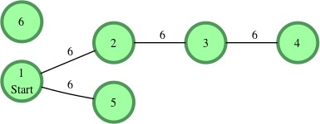

Starting from node 1and creating a list of distances, for nodes 2 through 6 we have distance
=[6,12,18,6,-1]

. Function Description
Define a Graph class with the required methods to return a list of distances. Input Format
The first line contains an integer, q, the number of queries. Each of the following q sets of lines is as follows: The first line contains two space-separated integers, n and m, the number of nodes and the number of edges.
Each of the next lines contains two space-separated integers, u and v, describing an edge connecting node u to node v.
The last line contains a single integer, s , the index of the starting node. Output Format
For each of the q queries, print a single line of n-1 space-separated integers denoting the shortest distances to each of the n-1 other nodes from starting position s. These distances should be listed sequentially by node number (i.e.,1,2 ,. n ), but should not include node . If
some node is unreachable from s , print -1as the distance to that node.

PRACTICE PROBLEMS
- Find BFS for the given graph

